August 29, 2019

Human Resources  
Gatsby Inc.

548 Market St. #36791  
San Francisco, CA 94104

### Re: [Staff Software Engineer, Learning Team](https://www.gatsbyjs.com/staff-software-engineer-learning-team/) position

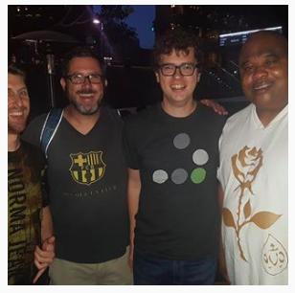I was excited to see your opening for the [Staff Software Engineer, Learning Team](https://www.gatsbyjs.com/staff-software-engineer-learning-team/) position via Instagram. I have been a fan of Gatsby for the past 2 years since Gatsby 1.0.0; I was an early adopter of Gatsby learning it via my mentor Phil Howley. Nevertheless, I have attended Gatsby meet up’s and met Kyle Mathews in July of 2018. That meeting with Kyle encouraged me to watch countless YouTube videos (particularly Jason Lengstrof Gatsby videos), I have participated in webinars, conference calls, read endless amounts of GitHub issues. I said of that to say that I am a real Gatsby JS FAN! I have made countless websites using Gatsby, teaching it to other aspiring web developers. When I noticed that you are hiring for the Learning Team I was compelled to apply.

I have read your job description and I believe that fit the requirements. I have included samples of my writing (ironically on the subject of Gatsby Headless websites). <https://74thstreet.net/The-new-new-thing/>

I have a background of public speaking, a real passion for web accessibility, proof reading editing documentation, teaching / explaining web development, building websites with HTML, CSS, and JavaScript. Lastly above all of the mentioned facts, I want this opportunity. I work on Gatsby project for the mere fun and passion for web development. It would be awesome to work at Gatsby!

### I am confident that I can offer you the [Staff Software Engineer, Learning Team](https://www.gatsbyjs.com/staff-software-engineer-learning-team/) position the skills you are seeking. Feel free to contact me at [aaron.earl.harris@me.com](mailto:aaron.earl.harris@me.com) or 323-481-0228 to arrange an interview. Thank you for your time—I look forward to learning more about this opportunity!

Sincerely,  
  
Aaron Harris